
WV Housing Development Fund
Project Management Tool

Version 1.0
July 16, 2026

Table of Contents
1 Login Directions 4
1.1 Link to OBPMT 4
1.2 Login Credentials 4
1.3 Login Page 4
2 OBPMT Navigation 5
2.1 OBPMT Landing Page 5
2.2 Map View 5
2.3 Table 6
2.4 Filters 7
2.5 Sort 10
2.6 Search 10
2.7 Export within the tables 11
2.8 Details Panel 12
3 Data Maintenance 13
3.1 Overview 13
3.2 Data Maintenance in the Project Editor Tool 13
3.2.1 Accessing the Editor App 13
3.2.2 Adding a Project 14
3.2.3 Updating a Record 15
3.2.4 Sorting Data 15
3.2.5 Searching Data 16
3.2.6 Filter 16
3.2.7 Export Table 17
3.3 Data Maintenance through SharePoint Site 18
3.3.1 Access Sharepoint 18
3.3.2 Adding and Editing Projects 19

Login Directions

Link to OBPMT

Login Credentials
- User:
- Password:

Login Page
The Login page should appear as:

When logging in, you may see this popup:
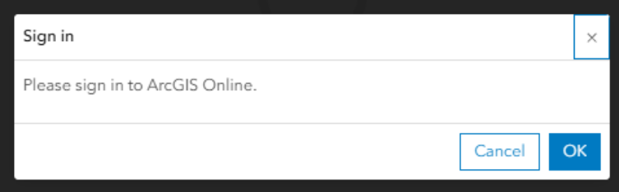
Please click “OK”, to continue to the OBPMT.

OBPMT Navigation

OBPMT Landing Page
The landing page should appear as:

Map View
To expand the map view, click the expand button on the top right of the map, that appears when your cursor is already on the map itself:

If you click on an individual project, it will bring up project specific details:

To leave the map view, click “Esc” button at the top left your keyboard.
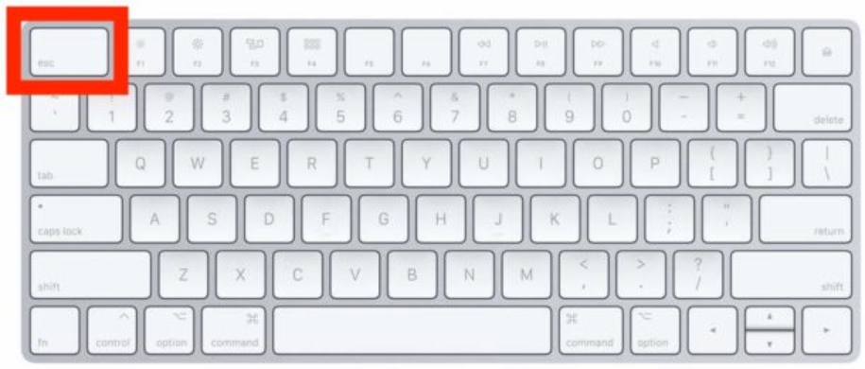

Table
The table initially displayed contains a full list of all WV Housing Development Fund projects. Scroll left and right using the slider at the bottom of the table to view project data:

Filters
The filter button will be on the top right corner. The dashboard has filters to select projects by Project Name, Description, Project ID, Project Status, Financial Status, and County. Selecting options on these filters will change the data in the map, table, indicators, and details panel.

Each filter can apply multiple selections, and the data will remain filtered until cleared. To apply a filter, click one of the boxes in the dashboard header:

Clicking on a filter box will expand its list. Either scroll in the list or use the search bar to find each option you would like to apply.

For instance, if you want to see completed project status, select the 'Completed ' option from the Project Status dropdown list.

To remove a filter, uncheck the box. Selected attributes will be shown will show on the table:

The dashboard can also be filtered by selecting data from the set filter tab by using a clause. Select the square with 4 circles highlighted in green and then select ‘set filter’:

Press Add, then clause and create the filter you would like. For instance, if you want to filter it to only see projects completed this would be the clause and press the box highlighted in green to show the selection on the table:

Sort
To sort, press the button highlighted in green. Clicking it once will sort ascending, clicking it twice will have it descend and clicking it three times will return it back to normal.

Search
To search click the button highlighted in green and type what you would like to search:

For instance, if you need to search up project status that are complete the table will give you the results (press X to reset the search):

Export within the tables
On the right corner of the table there will be a square with 4 circles, when clicking that press the export button and it will give you options on what to export, press export to csv:

If failed to execute download, try enabling all pop-ups in the browser by selecting “always allow pop-ups from...”
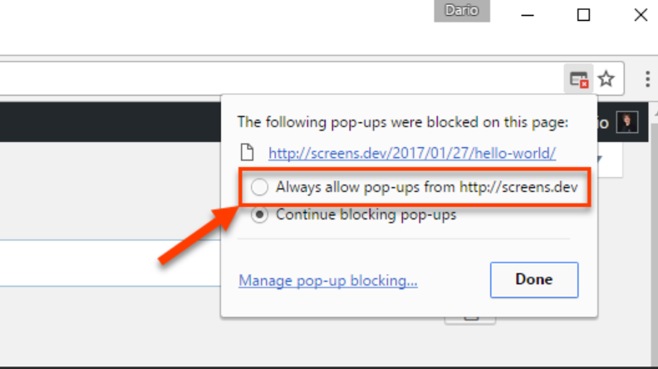

Details Panel
The details panel is on the right-hand side of the dashboard:

Select a project from the table to display its details and funding sources. Scroll through the top section of the column to read project details and view attachments. The bottom section of the column contains funding sources and amounts for the selected project.

Data Maintenance

Overview
ArcGIS Experience Builders are helpful tools hosted by Esri for creating interactive GIS applications and visualizing spatial data. The WVHDF Project Editor provides a user-friendly way to update, add, and interact with WVHDF projects in West Virginia.

Data Maintenance in the Project Editor Tool

Accessing the Editor App

Access through OBPMT
To access the editor, click the “WVHDF Projects Editor” tab at the top of the screen:

Access through WVHDF AGOL
West Virginia Infrastructure hosts the _.

Sign in with the credentials below where prompted and Sign In.

The application can be located within the West Virginia WVHDF Group. Click the “Groups” tab in the header.

The application can be found in the “Content” tab of this group.

Adding a Project
A new project can be added using the “Project Submission” tab on the left-hand side of the page. Ensure you are completing all required fields to continue and submit the form.
For the County field, please click the project’s county on the map displayed on the right-hand side of the page to complete this section of the form. The field will automatically fill with your selection, and any additional counties can be included in the drop-down list below. You can zoom in on the map to select the project’s primary county.

Once you have completed all required sections of the form, click the blue “Submit” button at the bottom to enter and view the new record in the Editor.

Updating a Record
Projects that have been submitted can be edited in the “Editor” tab located in the left-hand panel. To edit a record, make a single selection from the table in the center of the page. The details of this record will populate in the editor on the left.

Making any changes in the editor panel will enable the “Update” button that you should click once you are finished making your desired updates to the record.

Sorting Data
To sort, press the button highlighted in green. Clicking it once will sort ascending, clicking it twice will have it descend and clinking it three times will return it back to normal.

Searching Data
To search click the button highlighted in green and type what you would like to search, and results will show up on the table.

Filter
The dashboard can be filtered by selecting data from the set filter tab by using a clause. Press the square with 4 circles highlighted in green and then press the set filter. Set up a clause like you would for the dashboard. Your selection will show up on the table.

Export Table
On the right corner of the table there will be a square with 4 circles, when clicking that press the export button and it will give you options on what to export, press export to csv:

If failed to execute download, try enabling all pop-ups in the browser by selecting “always allow pop-ups from...”

Data Maintenance through SharePoint Site

Access Sharepoint
Data updates can be made using the WVHDF workbook on the SharePoint site here:
The sheet in this folder contains all projects submitted for the WV Housing Development Fund and updates daily at 11:00 PM for both the Agency and GOV layer in AGOL. Projects added through the editing application automatically update this sheet.

Adding and Editing Projects
To enter a new project, fill out all applicable fields on the next row under all submitted projects. Edits to projects listed here are able to be made directly within the sheet by modifying any cell. Follow the data type and format of exisiting projects.

